Template for Extended Abstracts, International Conference on Wood Adhesives
Instructions on first page, template following.
If possible, please prepare your extended abstract or manuscript using ‘MS Word’ word processing software. The document should be saved under the first author’s name, for example Jones.docx or Smith et al.doc. It can be save either as doc or docx format. Use Times New Roman, 10 pt, aligned flush left. All pictures, tables, and figures should be embedded in the text and centred. All margins should be 1”. Do not place any text outside of this area. Do not include page numbers, they will be added later. Do not include headers and footers of any kind.
All manuscripts should be in English. Metric units (SI) should be used. It is assumed that the corresponding authors grant us copyright to use the manuscript in the proceedings. Should the authors use tables or figures from other publications, it is assumed that permission has been obtained to do so. To emphasize a word or a phrase use italics.
Authors and affiliations: presenting author underlined. There is no length limit.

Use only three levels of headings:

FIRST LEVEL (abstract, intro, etc.)
Aligned flush left, all uppercase, 10 point bold. Note all fonts are already provided in Home/Styles menu bar at top

Second Level
Aligned flush left, 10 point bold, first letter of each word in uppercase.

Third level.
Aligned flush left, 10 pt bold, first letter of first word in uppercase, include a period at the end.
All headings should be in bold type. Double-space before and after first and second level headings.
Tables should be included in the text, where appropriate. A descriptive title should be given above the table. Units should be given in square brackets. An example is given below (Table 1).

Table 1: Results of test

Specimen | Length [m] | Width [m] | Height [m] | Weight [kg]
1ª | 1 | 1 | 1 | 1
2 | 2 | 2 | 2 | 2
3^{b} | 3 | 3 | 3 | 3
ªComment a, ^{b}Comment b

Figures should be referred to in text as Fig. 1, or as (Fig. 1) and should be presented as part of the text. A descriptive title should be given below the figure.
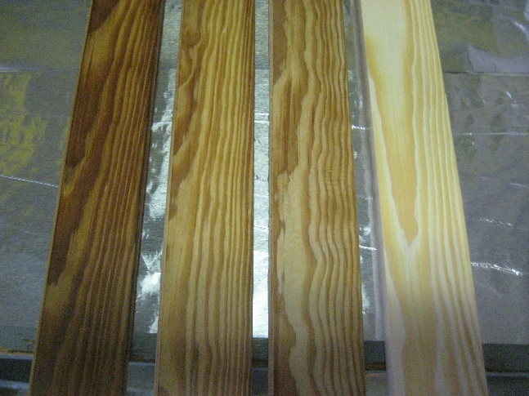
Figure 1: Hydro-thermally densified pine wood.

Title of Paper (in Title Case)
First Authorª, Presenting Authorª (Underlined), Third Author^{b}, Corresponding Authorª (bold)
a Affiliation: institution, location, email addresses
b Affiliation: institution, location, email addresses

ABSTRACT
Feel free to place your text inside this document.
To format a section of text, highlight the text then click on the style you want in Home/Styles.

INTRODUCTION

Materials and METHODS

Level 2 Header (note capitalized main words)

Level 3 header. (note period)

Results and Discussion

Conclusion

Acknowledgements

REFERENCES
Do not abbreviate journal titles. Cite references in the text using the author’s last name and date of publication as follows (Murphy 1990, Jones and Smith 1989, Davis et al. 1999).
Example:
Buschbeck L., Kehr E., Jensen U. 1961a. Untersuchungen über die Eignung verschiedener Holzarten und Sortimente zur Herstellung von Spanplatten – 1. Mitteilung: Rotbuche und Kiefer. Holztechnologie, 2, 2: 99–110
Kollmann F., Kuenzi W. E., Stamm J. A. 1975. Principles of Wood Science and Technology – Volume II: Wood Based Materials. Berlin, Heidelberg, New York, Tokyo, Springer–Verlag: 312–550
Xu W., Suchsland O. 1998. Variability of particleboard properties from single– and mixed–species processes. Forest Products Journal, 48, 9: 68–74

